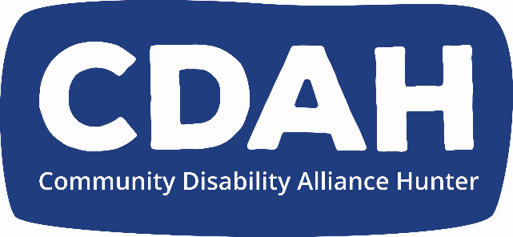

**CDAH Annual General Meeting Minutes(AGM)**

Meeting Date: **Thursday 21rd November 2024**

Meeting Time:  5.30pm

Meeting Venue: At the CDAH Office

Welcome

Emergency Procedure, introducing Telden as the fire warden

Attendance: Please say your own name,

In the room: Dave Belcher, Andrew Vodic, Michael Guy, Telden Nelson, Billie Mosman, Kimball Lance, Kristy Trajcevski, Julie Clifton, Enya Savory, Naomi Curry, Stephen Hallinan, Sam Dagg, Kate Davies, Alana Curtis, Peter Boyd, Katelijn Hullegie, Gail Tillman, Barbara Mannell, Erin Forrester, Brad Webb

On Zoom, Douglas Holmes, Juanita Vernon and Sarah Simmonds

Apologies: Tania Lewis, Stewart MacLennan, Sui Watts, Alicia Cooper, Kim Worthing, Karina Quero, Veronica Matheson, Cedar Whelan

Interpreter: Karen Lantry

Facilitation, Dave Belcher

Meeting Commenced: 5.30

Establish Quorum: (Quorum is a minimum of 5 full members) yes, quorum is established

Acknowledgment of Country: Andrew Vodic

Minutes of previous [Annual General Meeting 2023:](https://cdahunter.sharepoint.com/:w:/r/sites/board/_layouts/15/Doc.aspx?sourcedoc=%7B40B71CC1-FC5B-4115-999D-C4508844CBDA%7D&file=CDAH%20AGM%20Minutes-%202023.docx&action=default&mobileredirect=true)

Moved by Erin, seconded by Julie, carried by all

President’s Report: Kristy

This is Kristy’s last president's report, we all would like to thank Kristy.

Dear Members,

This year has been a year of consolidation for CDAH. We have survived a period of uncertainty created by the loss of one of our key project funding. Luckily we were able to strongly advocate for ourselves and secure a further extension. Our defining achievement of this year however, is the establishment of Disco. It is my hope that this will go from strength to strength and allow CDAH to eventually become self-sufficient and not be beholden to government funding.

As President I would like to thank all members and staff for taking a little organisation and making it into a strong robust community. We must continue to fight for the rights of people with disabilities. I believe the peer movement is an important tool in the advocacy landscape and we need to keep moving forward towards equality.

I would love to say a special thanks to everyone who I have worked with at CDAH. Especially, all the Boards I have worked with over the years, thank you to the current Board and Staff and CEO. I have especially loved working with Andrew Vodic and thank him for his energy vision and support. I thank all the staff around Andrew that support us both

Lastly, I thank the members for their support. We exist to serve your needs and you are the reason we are so strong. I am stepping down this year, but I look forward to seeing what CDAH can do under new leadership. I wish the new President well and hope that CDAH continues to go from strength to strength.

Thanks for everything,

Thanking Kristy, flowers and card

2023/2024 Financial Report including Audit: Judy Brown

Accepting the report, First Naomi, Billie Second carried by all

Executive Officer report: Andrew

Thanking everybody, we have used with Judy Brown as our auditor which is always really great.

We have had a hard year, having to fight for funding. It is what we do, and we know it is not easy, but it is what we do for our community.

It is great that all the members are involved and part of the organisation

Thanking the board for looking after us all.

Thank you, Kate Davies, our public officer.

Thank you to staff, all peers and allies and a thank you to Kellie Summers, who contributed a lot

Thanking Peergroup, Peer learning hub, peer groups, projects, everyone worked very hard. Deaf Blind hub are a huge asset and amazing.

Dave and Jamie in Disco, disability consultants

Community partners, organisations and individual that support us, and intepreters

From the constitution:

Part 4 General meetings of association

30. Annual General Meetings

(4) The business that may be transacted at an Annual General Meeting includes the following:

1. confirming the minutes of the previous annual general meeting and any special general meetings held since the previous annual general meeting,
2. receiving reports from the Board on the association’s activities during the previous financial year,
3. electing office-bearers and ordinary Board members,
4. receiving and considering financial statements or reports required to be submitted to members of the association under the Act.

Election of Returning officer, we nominate Dave

All in favour

Election of Board members:

Thanking the board again for their dedication to the CDAH

Board members who were nominated/elected at the November 2023 AGM were:

Stephen Hallinan, Erin Forrester and Billie, Billie they will not need to re-nominate this year, because their membership will roll over

Board members who do need to (re-)nominate are:

Enya Savory, Samantha Dagg and Naomi Curry

Nomination forms from Enya Savory , Samantha Dagg, Douglas Holmes and Naomi Curry have been received

Office Bearers nominations are

President, Naomi Ruth Curry

Vice president Erin Forrester

Treasurer, Samantha Miles Dagg

Secretary, Douglas John Holmes

Public officer

Kate Davies

Announcements:

Christmas Party date

Fri 13/12/2024 11:00 AM - 2:00 PM At Merewether Bowlo

Please stay and share some food (Pizza) and a drink

Meeting closed