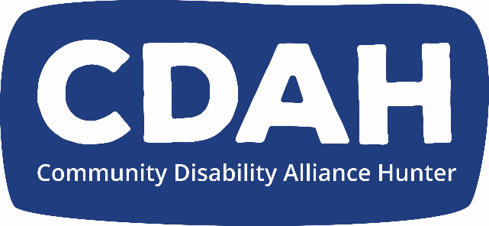

**CDAH Annual General Meeting Minutes (AGM)**

Meeting Date: **Thursday 23rd November 2023**

Meeting Time:  5.30pm

Meeting Venue: At the CDAH Office

Attendance: Sarah Simmonds, Julie Clifton, Douglas Holmes, Billie Mossman, Stephen Hallinan, Erin Forrester, Andrew Vodic, Leigh Creighton, Dave Belcher, Sam Dagg, Enya Savory (and Reggie- dog), Naomi Curry, Stewart McLennan, Shaylie Pryer, Owen Baird-Peddie, Tania Lewis, Veronica Matheson, Juanita Vernon

Associate members Katelijn, Suzy, Jarrod, Chelsie, Chris Morris, Kellie

Interpreters: Sarah Dearlove, Debbie Ellam

Public officer: Kate Davies

Auditor: Judy Brown

Apologies Cedar, Leah, Kristy, Geoff

Facilitation; Dave Belcher

Meeting Commenced: 5.30

Establish Quorum: yes - 18 full members

Acknowledgment of Country: Dave

President’s Report: Erin read on behalf of Kristy, who is at home with Covid

Minutes of previous Annual General Meeting:

Moved by Erin

Seconded by Douglas

All in favour

2022/2023 Financial Report including Audit

Judy Brown spoke about our audit and gave is an unqualified auditors report. So, congratulations

Billie moved and seconded by Stephen

Passed unanimously

Change of constitution and Special General Meeting

Douglas spoke about the changes to the constitution, which was passed unanimously at the Special General Meeting, which was held earlier today.

Second motion to extend Kristy’s tenure which was also passed unanimously.

We all thank and congratulate Douglas for all this great work

applause👏

Executive Officer report

Andrew

Firstly, Thank you Douglas

Would like to highlight,

* the groundwork we started on DisCo – cultural change consultant.
* It’s making some great progress
* Current membership is 134
* Spilling our membership and making sure that all CDAH membership, which might seem a nuisance, but it gives people control to make their own decisions. Thanks to all the members for their continued engagement!
* Work of the MAG, (Members Action Group) thank you Douglas again!
* Disability Royal Commission and NDIS review. Thanks to everyone involved and their contributions
* Thanks to all the members
* Thanks to all the allies and staff at CDAH
* Thanks to the board, they do an amazing job
* The public officer Kate Davies

Election of Board members:

Firstly, thanking the board again for their dedication to the CDAH values and great work

Nominations are:

Douglas, Kristy, Stephen and Billie, who don’t need to be elected, because there are fewer nominations than board vacancies

Rolling over from last year is Enya

Public officer

Kate Davies

Happy to be the public officer and congratulation on a really good year

Announcements

Watch party for Bill Shorten speaking at national press club, regarding the royal commission and government recommendations.

This will be in two weeks, Jarrod will share invitations via social media and email.

Thanks again, we have come through Covid and it has been tough for everyone, now it is great to see so many people at CDAH taking on leadership roles

Any other questions or announcements?

Douglas

Next Thursday 10.30 AM, workshop for pathways on Disco

Enya

News of a new Peer group for people ages 18 to 25 on 1st of December

Dave

Christmas Party on 8th of December at the Wicko 12PM

Please RSVP via

Please stay and share some food and a drink

Meeting closed