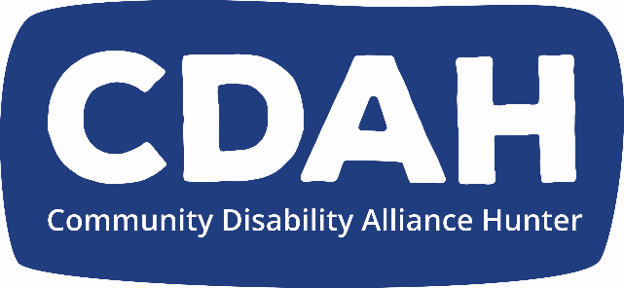

**CDAH Annual General Meeting Minutes (AGM)**

Meeting Date: **Thursday 21rd November 2024**

Meeting Time:  5.30pm

Meeting Venue: At the CDAH Office

Attendance:

Apologies:

Facilitation;

Meeting Commenced: 5.30

Establish Quorum: (Quorum is a minimum of 5 full members)

Acknowledgment of Country:

From the constitution:

President’s Report:

Minutes of previous [Annual General Meeting 2023:](https://cdahunter.sharepoint.com/:w:/r/sites/board/_layouts/15/Doc.aspx?sourcedoc=%7B40B71CC1-FC5B-4115-999D-C4508844CBDA%7D&file=CDAH%20AGM%20Minutes-%202023.docx&action=default&mobileredirect=true)

2023/2024 Financial Report including Audit

Judy Brown

Executive Officer report

Andrew

Part 4 General meetings of association

30. Annual General Meetings

(4) The business that may be transacted at an Annual General Meeting includes the following:

1. confirming the minutes of the previous annual general meeting and any special general meetings held since the previous annual general meeting,
2. receiving reports from the Board on the association’s activities during the previous financial year,
3. electing office-bearers and ordinary Board members,
4. receiving and considering financial statements or reports required to be submitted to members of the association under the Act.

Election of Board members:

Thanking the board again for their dedication to the CDAH

Board members who were nominated/elected at the November 2023 AGM were:

Kristy Stephen, and Billie they will not need to re-nominate this year, because their membership will roll over

Board members who do need to (re-)nominate are:

Enya, Sam and Naomi

Nomination forms from Enya Savory Sam Dagg Douglas Holmes and Naomi Curry have been received

Public officer

Kate Davies TBC

Announcements

Christmas Party date

Fri 13/12/2024 11:00 AM - 2:00 PM At Merewether Bowlo

Please stay and share some food and a drink

Meeting closed